** KENDRIYA VIDYALAYA NO. 3 JAIPUR**

**2022-23**

COMPUTER SCIENCE PROJECT

Topic:- BANK MANAGEMENT SYSTEM

Submitted by: Submitted to:

RUDRANSH SINGH Mr. Satish Jangir

SHREYANSH DUTT MEHRA

SHREYA KUMARI

CLASS: 12th ‘B’

**TABLE OF CONTENTS**

1. CERTIFICATE
2. ACKNOWLEDGMENT
3. AIM OF THE PROJECT
4. INTRODUCTION
5. WORKINGS
6. FLOW CHART
7. SOURCE CODE
8. OUTPUTS AND TABLES
9. BIBLIOGRAPHY

**CERTIFICATE**

This is to certify that Rudransh Singh, Shreyansh Dutt Mehra, and Shreya Kumari student of class XIIth (Sci.) has successfully prepared the report on the Project entitled " BANK MANAGEMENT SYSTEM " under the guidance of Mr. Satish Jangir. The report is the result of his efforts & endeavors. The report is found worthy of acceptance as the final Project report for the subject Computer Science of class XIIth (sci.).

Subject Teacher External Examiner

___________ _____________

**ACKNOWLEDGMENT**

Apart from our efforts, the success of any project depends largely on the encouragement and guidelines of many others. We take this opportunity to express our special gratitude to our subject teacher **Mr. Satish Jangir sir**, A guide, Mentor above a friend, who critically reviewed my project and helped in solving each problem, that occurred during the implementation of the project

**AIM OF THE PROJECT**

The objective of this program is to use the knowledge of computer science in real-world situations and expose the students to how programming skills can help in making good software and make data collection easier. In this project, we will utilize modern tools and write effective procedural code to solve small to medium size problems.

**INTRODUCTION**

The knowledge of Computer science can be used for many things. The storage of data by any company is difficult in hard copies and can also be challenging to find data from one person in all databases. This can be solved using computer science. Here we are going to introduce a project with the help of python and MySQL. In the project, we are going to use data and insert it through python, and store it in the MySQL database.

**Workings**

This is a menu-driven program so by using a while loop we take input choices from the user to operate the system.

The first choice is creating a bank account, in which we take input from customers’ details and add these values to the ‘customer_details’ table. The second choice is to make a transaction, in which we give the user a choice of either withdrawing the amount or adding the amount. If the user chooses to withdraw the amount then we take input of the withdrawal amount and update the “customer_details” table by subtracting the withdrawal amount from the account balance. After that, we insert new details into the “transactions” table containing account no., date, amount added, and withdrawal amount. If the user chooses to add an amount then we do the same thing but instead of subtracting from the account balance, we add the amount. The third choice is to view customers' details by account number, we fetch the customer’s details, and using for loop we display the details. The fourth choice is to view the transaction details of a customer, which fetches all the transaction history of specific account no. from the “transactions” table and prints them one by one using for loop. The fifth choice is to delete an account using the account number which is done using the statement “delete from customer_details where acc_no = (account number)”. The final choice is to exit the program, which ends the while loop which was running the menu.

**Modules Used:**

* mysql.connector

By importing this package, we are able to establish the connection between SQL and python.

* datetime

**Functions Used:**

* connect ():

This function establishes connection between python and MySQL.

* curson():

It’s a special control structure that facilitates the row-by-row processing of records in the result set.

* execute():

This function is used to execute the sql query and retrieve records using python.

* fetchall():

This function will return all the rows from the result set in the form of a tuple containing the records.

* fetchone():

This function will return one row from the result set in the form of a tuple containing the records.

* commit():

This function provides changes in the database physically.

**Our project contains 2 MySQL tables:**

1. customer_details
2. transactions

The table customer_details contain following columns:

1. acc_no
2. acc_name
3. ph_no
4. address
5. cr_amt

The table transactions contain following columns:

1. acct_no
2. dt.datetime.today(),
3. w_amt
4. a_amt

**Flow Chart**







**SOURCE CODE**

**For MySQL:**

create database bank;

use bank;

create table customer_details(acc_no int primary key,acc_name varchar(50),ph_no int,address varchar(90), cr_amt int);

create table transactions(acc_no int,Date date,w_amt int, a_amt int);

**For Python:**

import datetime as dt

import mysql.connector as sql

conn=sql.connect(host='localhost',user='root',passwd='manager',database='bank')

cur = conn.cursor()

conn.autocommit = True

c = 'n'

while c == 'n' or c == ’N’:

print()

print('1.CREATE BANK ACCOUNT')

print()

print('2.TRANSACTION')

print()

print('3.CUSTOMER DETAILS')

print()

print('4.TRANSACTION DETAILS')

print()

print('5.DELETE ACCOUNT')

print()

print('6.QUIT')

print()

n=int(input('Enter your CHOICE='))

print()

if n == 1:

acc_no=int(input('Enter your ACCOUNT NUMBER='))

print()

 acc_name=input('Enter your ACCOUNT NAME=')

print()

ph_no=int(input('Enter your PHONE NUMBER='))

print()

address=(input('Enter your place='))

print()

cr_amt=int(input('Enter your credit amount='))

V_SQLInsert="INSERT INTO customer_details values (" + str (acc_no) + ",' " + acc_name + " ',"+str(ph_no) + ",' " +address + " ',"+ str (cr_amt) + " ) "

cur.execute(V_SQLInsert)

print()

print('Account Created Succesfully!!!!!')

conn.commit()

if n == 2:

acct_no=int(input('Enter Your Account Number='))

cur.execute('select * from customer_details where acct_no='+str (acct_no) )

data=cur.fetchall()

count=cur.rowcount

conn.commit()

if count == 0:

print()

print('Account Number Invalid Sorry Try Again Later')

print()

else:

print()

print('1.WITHDRAW AMOUNT')

print()

print('2.ADD AMOUNT')

print()

print()

x=int(input('Enter your CHOICE='))

print()

if x == 1:

amt=int(input('Enter withdrawl amount='))

cur.execute('select cr_amt from customer_details where acct_no='+str(acct_no))

data=cur.fetchone()

if amt>data[0]:

print('insufficient amount')

else:

cr_amt=0

cur.execute('update customer_details set cr_amt=cr_amt-'+str(amt) + ' where acct_no=' +str(acct_no) )

V_SQLInsert="INSERT INTO transactions values ({} , '{}' , {} , {}) ".format(acct_no,dt.datetime.today(),amt,cr_amt)

cur.execute( V_SQLInsert)

conn.commit()

print()

print('Account Updated Succesfully!!!!!')



if x== 2:

amt=int(input('Enter amount to be added='))

cr_amt=0

cur.execute('update customer_details set cr_amt=cr_amt+'+str(amt) + ' where acct_no=' +str(acct_no) )

V_SQLInsert="INSERT INTO transactions values ({} , '{}' , {} , {}) ".format(acct_no,dt.datetime.today(),cr_amt,amt)

cur.execute( V_SQLInsert)

conn.commit()

print()

print('Account Updated Succesfully!!!!!')

if n == 3:

acct_no=int(input('Enter your account number='))

print()

cur.execute('select * from customer_details where acct_no='+str(acct_no) )

if cur.fetchone() is None:

print()

print('Invalid Account number')

else:

cur.execute('select * from customer_details where acct_no='+str(acct_no) )

data=cur.fetchall()

for row in data:

print('ACCOUNT NO=',acct_no)

print()

print('ACCOUNT NAME=',row[1])

 print()

print(' PHONE NUMBER=',row[2])

print()

print('ADDRESS=',row[3])

print()

print('cr_amt=',row[4])

if n == 4:

acct_no=int(input('Enter your account number='))

print()

cur.execute('select * from customer_details where acct_no='+str(acct_no) )

if cur.fetchone() is None:

print()

print('Invalid Account number')

else:

cur.execute('select * from transactions where acct_no='+str(acct_no) )

data=cur.fetchall()

for row in data:

print('ACCOUNT NO=',acct_no)

print()

print('DATE=',row[1])

print()

print(' WITHDRAWAL AMOUNT=',row[2])

print()

print('AMOUNT ADDED=',row[3])

print()

if n == 5:

print('DELETE YOUR ACCOUNT')

acct_no=int(input('Enter your account number='))

cur.execute('delete from customer_details where acct_no='+str(acct_no) )

print('ACCOUNT DELETED SUCCESFULLY')



if n == 6:

print('DO YO WANT TO EXIT(y/n)')

c=input ('enter your choice=')

else:

print('THANK YOU PLEASE VISIT AGAIN')

quit()

**OUTPUTS**

* **CREATING BANK ACCOUNT**

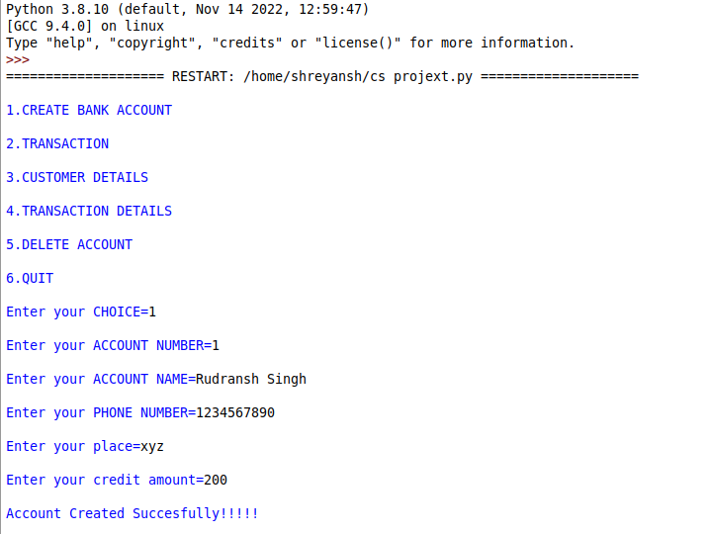

* **TRANSACTION(AMOUNT WITHDRAWAL)**

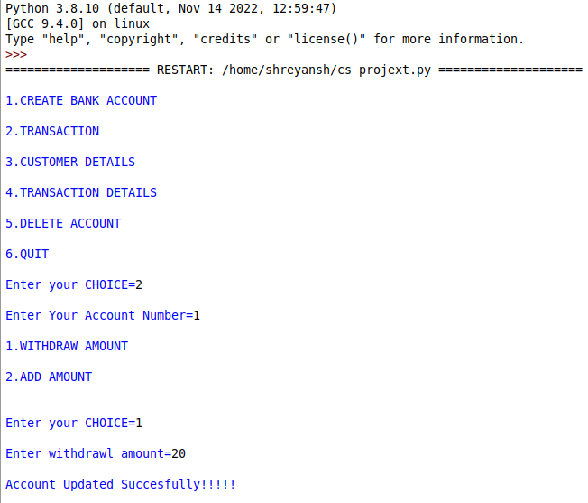

* **TRANSACTION(AMOUNT ADDITION)**

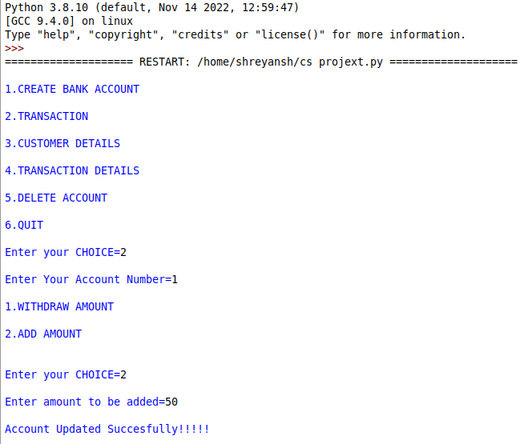

* **CUSTOMER DETAILS**

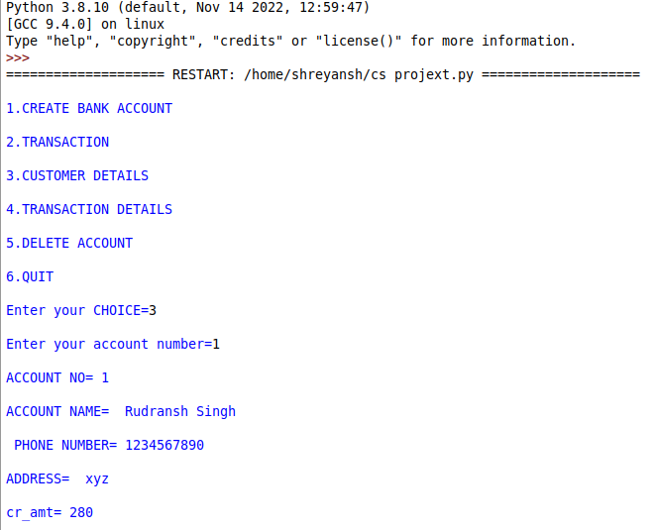

* **TRANSACTION DETAILS**

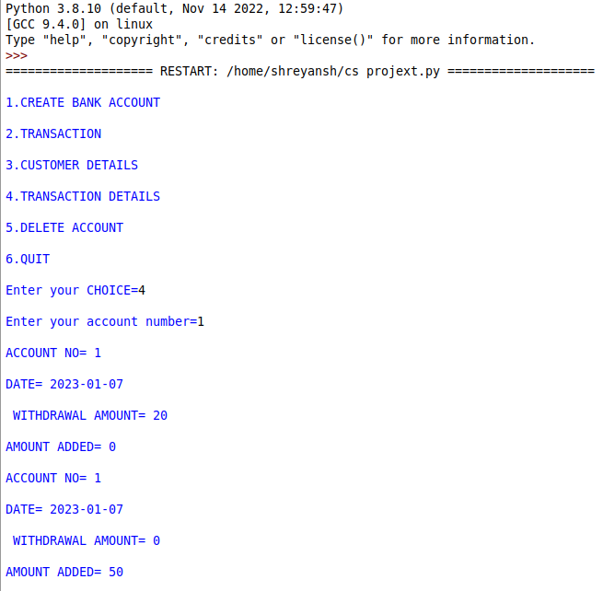

* **DELETE ACCOUNT**

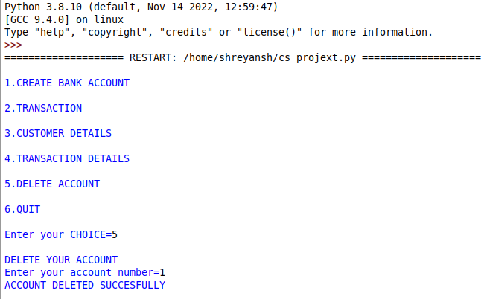

**TABLES**

CUSTOMER_DETAILS

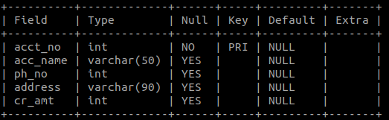

TRANSACTIONS

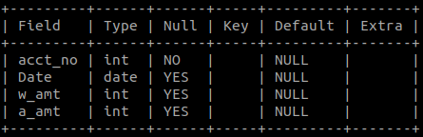

BIBLIOGRAPHY

* Sunita Arora of class 12
* Preeta Arora of class 12
* By our teacher
* CLASS XII NCERT COMPUTER SCIENCE